12th May 2011

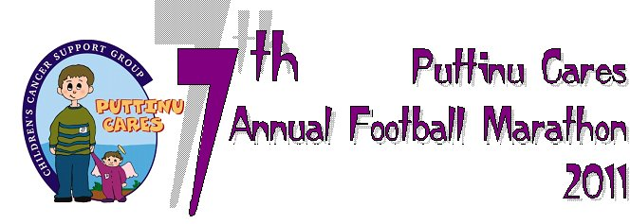

Dear Monalisa

On behalf of the children who come to Rainbow Ward for treatment, the adults receiving treatment for cancer, their families, the staff and all the members of the Puttinu Cares Children’s Cancer Support Group, we would like to sincerely thank you for your participation in the 7th Annual Football Marathon. Your efforts and kindness were invaluable in making this marathon a huge success, and you helped us in achieving our aims, mainly in improving the morale and increasing help for the families of young children and adults suffering from cancer, and in creating awareness of this painful reality.

For the last 7 years, Puttinu Cares’ dream has been to be a haven of solace for families whose children have been afflicted by cancer, and, special and caring people like you, help us in making this dream a reality. You were part of the magical and colorful atmosphere that, together as a team, we offered to the thousands of people who visited us at the Puttinu Funpark at the Marsa Sports Complex and we cannot thank you enough for being part of this wonderful celebration. Your presence and support was much appreciated.

We all applaud you for a job well done! Thank you for taking time out from your busy schedule to share this wonderful experience with us.

We would be honored to have you with us again in the future, should your schedule permit.

**Please accept our heartfelt thanks.**

Maureen, Rita and Elvia

***Puttinu Cares Funpark Team***